**Gas Leakage Monitoring and Alerting System**

**Solution Architecture**

# Problem Statement

Workers who are engaged with a busy industries packed with gas either harmful or harmless needs a way to monitor their gas pipelines continuously and detect early if there is any leakage of gas in their surroundings so that they can work efficiently on major crises rather than worrying about monitoring or leakage of gas, this will indeed reduce the manpower of that industry and create a peaceful environment.

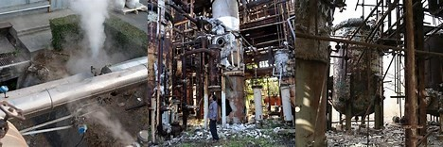

# Solution Statement

The system can be taken as a small attempt in connecting the existing primary gas detection methods to a mobile platform integrated with IoT platforms. The gases are sensed in an area of 1m radius of the rover and the sensor output datas are continuously transferred to the local server. The accuracy of MQ sensors are not upto the mark thus stray gases are also detected which creates an amount of error in the outputs of the sensors, especially in case of methane. Further the availability and storage of toxic gases like hydrogen sulphide also creates problems for testing the assembled hardware. As the system operates outside the pipeline, the complication of system maintenance and material selection of the system in case of corrosive gases is reduced. Thus the system at this stage can only be used as a primary indicator of leakage inside a plant.

